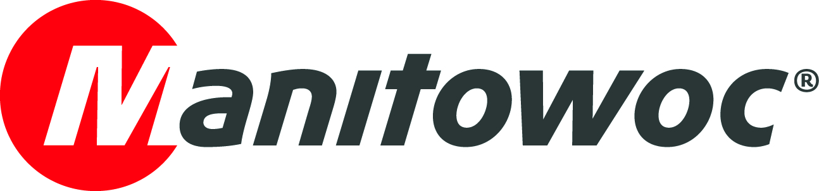
NEWS RELEASE
January 14, 2021

MSG Krandienst strengthens fleet with new four- and five-axle Grove cranes

- At the end of October 2020, Manitowoc handed over a new Grove GMK4100L-1 and a Grove GMK5150L to MSG Krandienst at its Wilhelmshaven factory.
- Following the GMK6300L-1, these are the second and third Grove all-terrain cranes MSG Krandienst received in 2020.
- MSG Krandienst’s positive experiences with previous Grove cranes, in particular their flexibility, maneuverability and reliability in combination with high capacities, were a key factor in the purchase decision.

After taking delivery of a Grove GMK6300L-1 in February 2020, MSG Krandienst (MSG) took delivery of its new GMK4100L-1 and GMK5150L at the Manitowoc factory in Wilhelmshaven, Germany, in October. The new all-terrain cranes from northern Germany will strengthen the capabilities of MSG’s primary location in Kehl, Baden-Württemberg, with the GMK5150L replacing its predecessor, a GMK5130-2, and the GMK4100L-1 replacing a competitor crane.

MSG currently offers customers a total of 16 Grove cranes from its four locations in Germany and France, ranging from the GMK3060 to the GMK6400. MSG’s five, five-axle Grove cranes form an integral part of the fleet. Their high capacities, flexibility and manueuverability lead to the cranes being frequently deployed for the assembly of precast concrete and steel construction elements, or as auxiliary cranes in the wind power sector.

MSG has been running a GMK5150L from the Freiburg site for the last three years. Managing director Björn Jatz said of the decision to repurchase: “The Grove GMK5150L is a reliable crane with a 60 m mast and 11.8 t load capacity on the long main boom. We have had a very good experience with its performance so our decision to purchase another GMK5150L was a quick one.”

The new GMK5150L has several extras, including aluminum alloy wheels, the Manitowoc Birdview 270° camera system that improves the operator visibility and a 17.8 m hydraulic swingaway jib.

“The jib comes into play when we are carrying out special chimney filter changes in steel mills, for example, or completing roof work from a distance. That’s when we need the strong load charts and long reach the 150 t Grove offers us,” Jatz explained.

Any job site, anywhere
The second new Grove all-terrain crane to join the MSG fleet, the GMK4100L-1, left the factory in Wilhelmshaven even before the official crane handover ceremony for its first job erecting a tower crane in Freiburg. The taxi load charts combined with the compact design is particularly impressive on this 100 t crane. With a vehicle width of just 2.55 m, it can easily travel to even the most confined city center job sites. The GMK4100L-1 can carry up to 6.7 of counterweight with 12 t per axle and has a towering 60 m main boom.

“With a 48 t driving permit, the crane can be moved to any project comprehensively. The MEGATRAK independent suspension on the GMKs is another unique selling proposition for Grove. It gives us the necessary ground clearance when the terrain off-road becomes more difficult,” Jatz said. “The GMK4100L-1 is also the second of MSG’s cranes to have the same construction. Given the § 29 driving permit in Germany, in the future, it will be essential to have identical machines in the fleet.”

Longstanding trust and partnership
At the crane handover, Andreas Werner, managing director, and Lukas Brämer, sales representative for dealer KranAgentur Werner, thanked MSG for their many years of trust and friendly cooperation: “Thank you for the great collaboration and for a long-standing partnership that has always been characterized by mutual trust.”

Since 1994 MSG Krandienst has supported customers’ projects with complex crane services, safe transport of heavy loads and effective project logistics, all tailored to their individual needs. The company has grown significantly over the last few decades and now employs 120 people across four locations in Germany and France. In addition to the headquarters in Kehl, there are branches in Freiburg-Teningen in Germany, and Strasbourg and Mulhouse in France.

Visit the Manitowoc website to learn more about Grove GMK4100L-1 and GMK5150L all-terrain cranes.

-END-

Image captions

Image 1: Lukas Brämer, sales representative at KranAgentur Werner; Alfred Jatz, partner at MSG Krandienst; Björn Jatz, managing director of MSG Krandienst; and Andreas Werner, managing director of KranAgentur Werner, celebrate the handover of the new Grove cranes.

Image 2: MSG Krandienst’s new GMK5150L and GMK4100L-1 before the handover at the Manitowoc factory in Wilhelmshaven, Germany.

CONTACT
Insa Heim
Marketing Communication Manager | Mobile Cranes Europe & Africa
Manitowoc
T +49 4421 294 4170
insa.heim@manitowoc.com

ABOUT THE MANITOWOC COMPANY, INC.
The Manitowoc Company, Inc. (“Manitowoc”) was founded in 1902 and has over a 117-year tradition of providing high-quality products and support services that are tailored to customers’ needs. Its 2019 net sales were approximately $1.83 billion. Manitowoc is one of the world's leading providers of engineered lifting solutions. Through its wholly-owned subsidiaries, Manitowoc designs, manufactures, markets and supports comprehensive product lines of mobile telescopic cranes, tower cranes, lattice-boom crawler cranes, boom trucks and industrial cranes under the Grove, Potain, Manitowoc, National Crane, Shuttlelift and Manitowoc Crane Care brand names.

THE MANITOWOC COMPANY, INC.
One Park Plaza — 11270 West Park Place — Suite 1000 — Milwaukee, WI 53224, USA
T +1 414 760 4600
www.manitowoc.com

